**Abstract**

**Data­Tag** is a Natural Language Processing based system which tags textual data and webpages in an intelligent way. Data­Tag solves the problem of ambiguity between similar words in a text and use a more semantic approach so as to classify data according to the context it is used in.

It uses **Python NLTK library** to tokenize the text snippet and extract valuable information about the text using these tokens. It further employs **Word Sense Disambiguation**(WSD) algorithm to find the most probable context of input text using multiple glosses through **Wikipedia API.**

In contrast to other Keyword based classification systems Data­Tag works more intelligently and extends the basic property of WSD to provide multiple classes to input data.

**List of Figures**

1. **Introduction**

Figure 1. DFD Modelling of Problem………………………………………......…2

1. **Function Oriented Design for procedural approach**

Figure 2. DFD of Application………………………………………………..........…8 Figure 3. DFD of Process­2 of Application…………………………………......…...9 Figure 4. DFD of Process­3 of Application…………………………………….........9 Figure 5. Activity Diagram of Request­Response……………………..……….....…10

1. **GUI Design**

Figure 6. Screenshot of Url Field Form………………………………...………....11

Figure 7. Screenshot of Text Field Form…………………………………..….......12

Figure 8. Screenshot of Results ……………………………………………….......13

1. **Coding**

Figure 9. Lesk Algorithm for Overlap Score……………………………………..14 Figure 10. Fetch content from url………………………………………………....14

1. **Testing**

Figure 11. Test Report……………………………………………………………..15

**Table of Contents**

1. INTRODUCTION…………………………………………….….……**...............**1

1.1. Purpose & Scope....………………………………….. ……**........................**1

1.2. System Overview…………………………………………......**.....................**1

1.3. Problem Statement…………………………………………….…**.................**1

1.4. Literature Survey**...........................................................................................**2

1.4. DFD Modelling of Problem**........……………………….…………………...**2

1.5. Goal & Vision………………………………………...……………**..............**3

2. REQUIREMENTS SPECIFICATIONS………………………………......……...4

2.1. User Characteristics…………………………………….………**…................**4

2.2. Functional Requirements……………………..………………....…**...............**4

2.3. Performance Requirements…………………………………….…**….............**5

2.4. Hardware Requirements……………………………………….….…**.............**6

2.5. Constraints & Assumptions………………………..……….…………**...........**6

2.7. Scheduling……………………………………………………...……**.......**..**....**7

3. DESIGN**..............................................………………………………………......**.8

3.1. Function Oriented Design for procedural approach(UML)…………….........8

3.2. Database Design………………………………….............………………..….10

3.3. GUI Design for frontend………………………………………………….......11

4. CODING(Sample 4-5 pages)………………………………………………...…....14

5. TESTING………………………………………………………………….............15

5.1. Test Plan(Unit Testing)…………………………………………………..…....15

5.2. Test Report……………………………………………………………….........15

6. RESULT.......................................……………………………………………..…..16

7.CONCLUSION & FUTURE WORK.....................................................................17

8.ENDUSER...............................................................................................................18

9. FUTURE WORK…………………………………………………..…………........19

10. REFERENCE……………………………………………… ……………….........20

APPENDIX (optional)

1. **Introduction**

This section gives a scope description and overview of everything included in this Project Report. Also, the purpose for this document is described and system overview along with goal and vision are listed.

**1.1. Purpose**

The purpose of this document is to give a detailed description of Data­Tag Project. It will illustrate the purpose and complete declaration for the development of system. It will also explain system constraints, interface and interactions with Wikipedia API. This document is primarily intended to anyone who wants to get an overview of how Data­Tag works, its outcomes and possible usages in future.

**1.2.** **System Overview**

Data­Tag takes as input a **plain text** or a **web url** and tokenize it to filter out meaningful words from the input text. This process is done by employing NLP techniques via NLTK library, which helps in fetching the **noun terms** out of the input text and pass these to Wikipedia API. The contents of related pages are fetched through **Wikipedia API** to be used as glosses for WSD algorithm. Finally it outputs most probable tags/classes of input text along with their definitions.

**1.3.** **Problem Statement**

We encounter a lot of textual data or web pages during an odd day, and most of the time it is desirable to get a quick overview of what this text of web page is about. Data­tag solves this problem by semantically tagging the textual data or web pages according the the context they are used in. It also provides a mechanism to classify textual data or web pages more intelligently in contrast to keyword based system.

2

**1.4.** **DFD Modelling of Problem**

As apparent from the DFD model of problem given on next page, Data­Tag takes a textual document as input. Data­Tagger application uses content of Wikipedia Pages fetched from Wikipedia Database via Wikipedia API. Tagged document along with summary of tags is the output of the system.

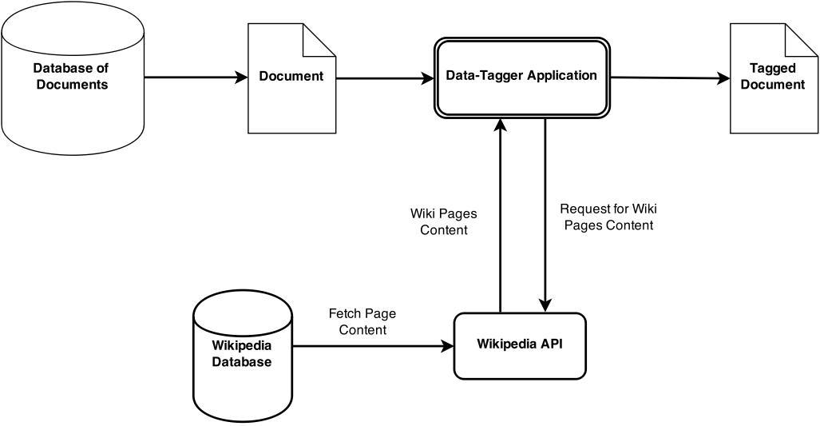

Figure 1. DFD of a Problem

**1.5.** **Goal & Vision**

This systems aims for a more semantic text/web page classification systems. Goal of Data­Tag is to provide an alternative for keyword based tagging systems, which is more intelligent and and comprehensible in nature.

This system can prove to be a basis for most of the web search/crawlers to employ similar NLP techniques in order to classify web pages based on the context they are used in and not merely on not so intelligent typical SEO techniques.

3

Data­Tag will further provide an user with a much more understandable definitions of the classes or tags related to the input text, so that a user don’t need to go through the whole of the document to get an idea of the context.

4

1. **Requirements Specification**

**2.1. User Characteristics**

There are two types of users that interact with the system :

* Users of the web application
* Other Web Applications

Each of these types of users has same use of the system that both these users want to tag a piece of text or a non­HTML(or plain text) content of web url but interact with the system in different modes.

The web application users interact with this application through a web browser. This web portal of this application presents a form for a user and form has two fields : one for web­page url and other for text , so user have to at least fill one of the field . On submit the form , application takes input values , tag the data and show the results on same web portal.

Other web applications are those applications like bots, third­party application , can also use this application through it web api. All requests should meet the specifications of application api.

**2.2.** **Functional Requirements**

**2.2.1.** **User Class 1 ­ The User**

**2.2.1.1.** **Functional Requirements 1.1**

**Actor:** User

**Input**: Feed Text as Input

**Description**: Given that user has access to the system through the internet.

User can provide the text input directly to process and analyze the results.

5

Text input goes to process in the background and instant result will be returned.

**2.2.1.2.** **Functional Requirements 1.2**

**Actor:** User

**Input**: Feed URL as Input

**Description**: Given that user has access to the system through the internet.User can provide the URL (Universal resource locator)/ hypertext link (valid) input directly to process and analyze the results. Link/URL input goes to process in the background to extract text and processed text will be instantly result will be returned.

**2.3. Dependencies**

Data­tag application has a web portal for user interaction and a REST Web API

for frontend and backend interactions or third­party application interactions.There are used very modern frameworks for developing its front­end and backend.

* **Angular JS :** This is javascript framework used for developing front­endof this application.
* **Flask:** This is a python framework used for developing back­end of thisapplication.

There are many third­party python libraries used in this application for performing various tasks, the list is as follows:

1. Flask
2. Flask­cors
3. NLTK
4. Numpy
5. Pattern
6. GRequests

6

1. PyQuery
2. Wikipedia
3. Redis
4. Urllib3
5. Rq
6. Redis­collections

**2.4.** **Performance Requirements**

Since the system use REST based server client architecture, and use the large source information from distant server, it fetch data from internet. Internet bandwidth is major performance parameter. As System uses wikipedia as source of massive data, multiple request and response is needed to handle in quicktime for instant result back to user.

Large system queries is handled by the fast operating systems for both the mobile and the web based process. Worker are used to provide faster HTTP Request handling.

**2.5.** **Hardware Requirements**

To access a web portal of this application, its only need a PC/Laptop/Mobile with an integrated and updated web browser.

**Desktop browser** : Safari, Chrome, Firefox, Opera, IE9+.

**Mobile browsers** : Android, Chrome Mobile, iOS Safari.

On the server side , a PC/Web Server which meets these specifications:­

1. Ubuntu Operating System
2. At least 2 GB RAM and 150 GB Free Space
3. Redis Server Installed
4. Python Compiler Installed

7

**2.6.** **Constraints & Assumptions**

**Data­Tag** only returns three tags per document/web url provided as an input,irrespective of the length of the input data. Reasons for this is that we came to found after excessive testing that Data­Tag may not provide as accurate results with larger number of tags. So we have fixed number of tags to be returned to a maximum of three tags.

It also assumes that the input is meaningful data and not some random characters. Any word in input which is not found in a standard dictionary may result in inaccurate tags.

For now, Data­Tag only supports “English” Language and will not work with any other languages.

8

1. **Design**

**3.1.** **Function Oriented Design for procedural approach**

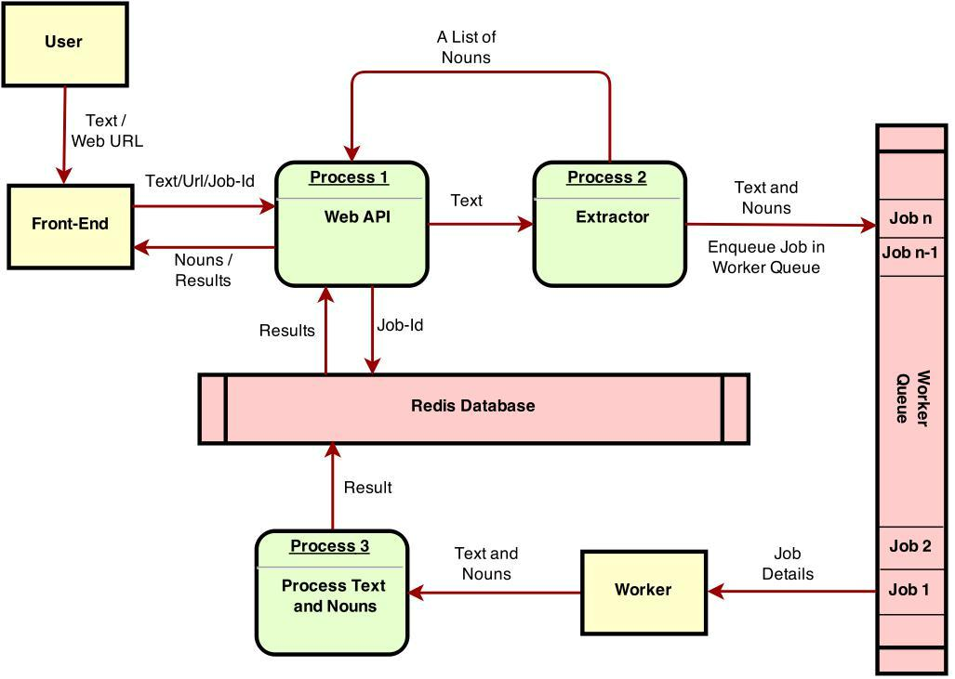

Figure 2. DFD of Application

9

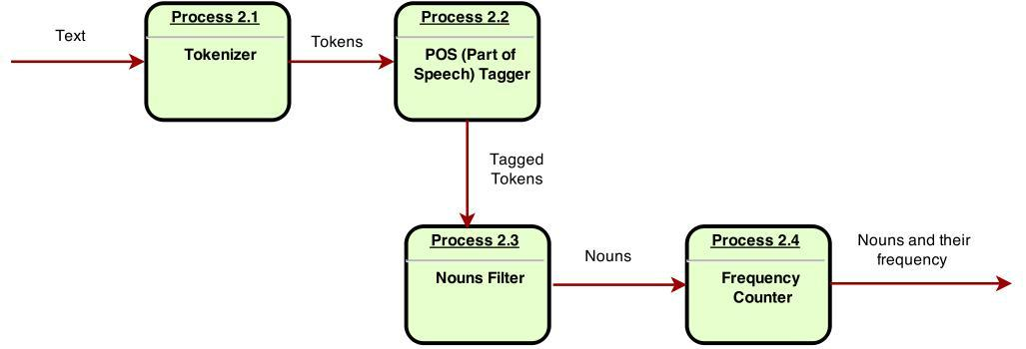

Figure 3. DFD Process 2 of Application

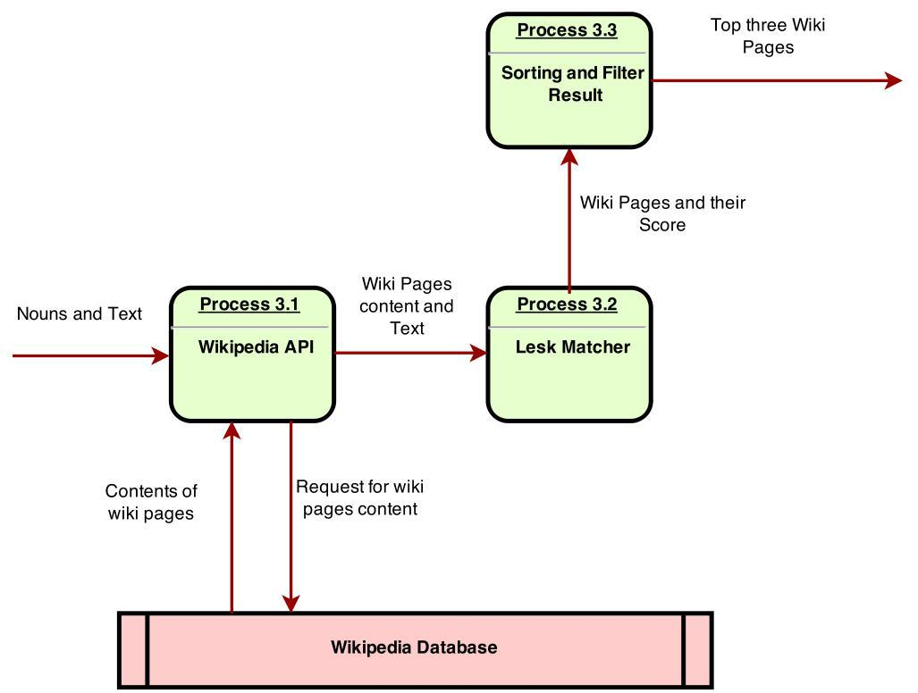

Figure 4. DFD Process­3 of Application

10

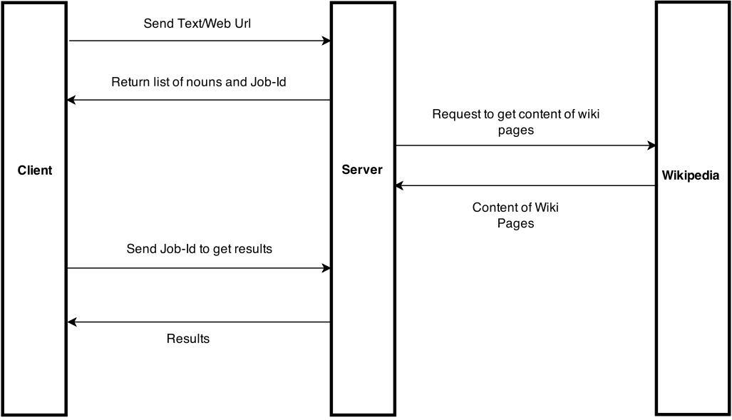

Figure 5. Activity Diagram of Request­Response

**3.2. Database Design**

Database used for this application is Redis Database which came inbuilt in a

Redis Server. It's a **"NoSQL" key­value data store**. More precisely, it is a ***data*** ***structure server***. The closest analog is probably to think of ***Redis*** as ***Memcached***,but with **built­in persistence** (snapshotting or journaling to disk) and **more data** **types**.Persistence to disk means you can use Redis as a real database instead ofjust a volatile cache. The data won't disappear when you restart, like with memcached.

This database is used to store details of each job enqueued in a worker queue and also the results of each job . When user made request to tag the data , then application create a new job for this request and enqueue a that job and also stores

11

that job details as a key­value in a database. Worker enqueued job and also fetch the particular details of that job from database and process the job. On completion, worker saves the result in the database, so that application can fetch those results on a request made for result retrieval.

For storing Python dictionary , which contains the information regarding job, a python library named **redis­collections** used for parsing python data types to string as redis can store only strings . Every operation of python related to that data types atomically changes data in Redis.

Dictionary for each Job stores details , which are as follows:

* **Job­Id** : Unique Id of Job
* **Text** : Text to be tag
* **All_Nouns** : All nouns in a text found
* **Nouns** : nouns to picked for wikipedia content fetching
* **Result** : result i.e a list of top­three wiki­pages object

**3.3.** **GUI Design for Front­end**

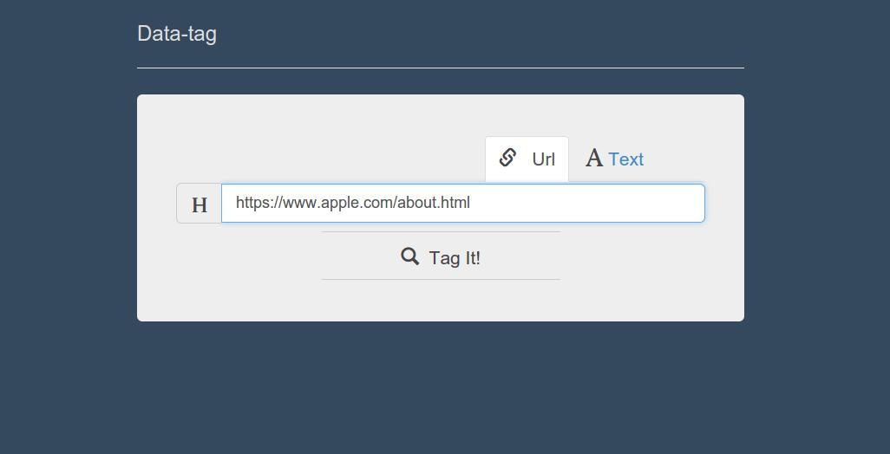

Figure 6. Screenshot of Url Field Form

12

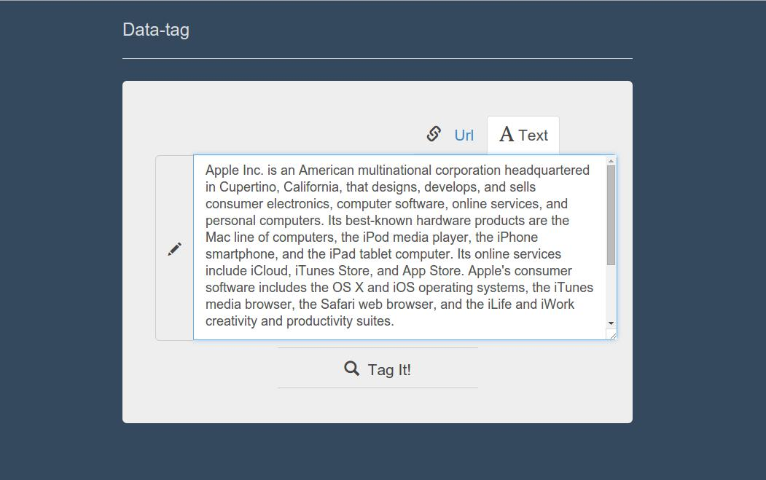

Figure 7. Screenshot of Text Field Form

13

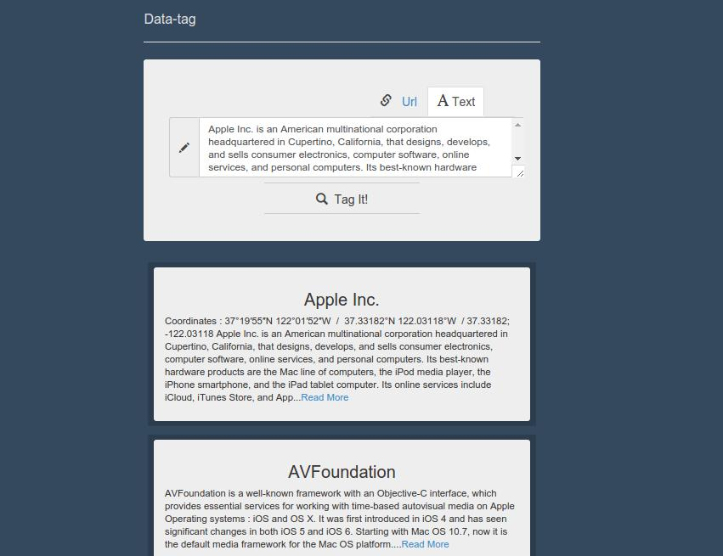

Figure 8. Screenshot of Results

14

1. **Coding**

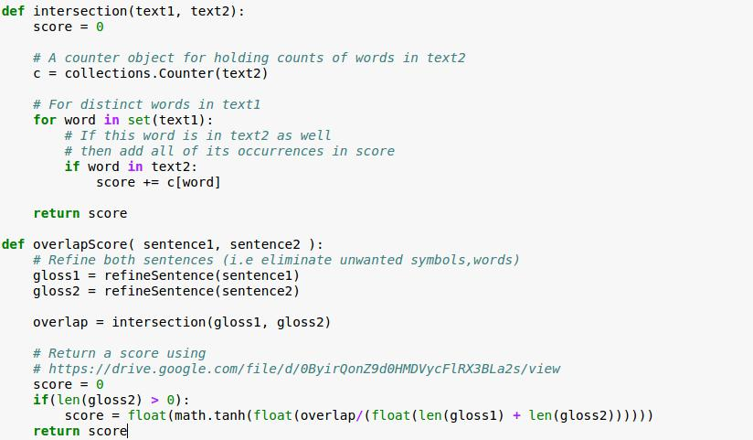

Figure 9. Lesk Algorithm for Overlap Score

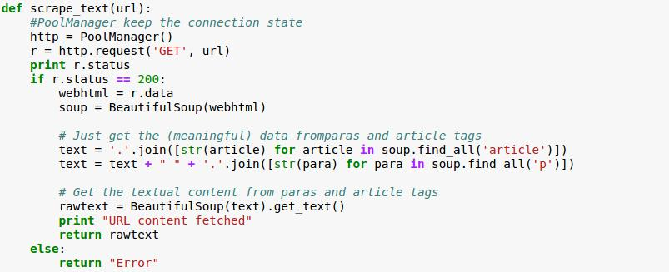

Figure 10. Fetch content from url

15

1. **Testing**

**5.1. Test Plan**

**Unit Testing:** Unit testing is a software development process in which the

smallest testable parts of an application, called units, are individually and independently scrutinized for proper operation. Unit testing is often automated but it can also be done manually. A unit test is an automated piece of code that invokes a ***unit of work*** in the system ***and then checks a single assumption about*** ***the behavior of that unit of work***.

In this application , a manually written unit test script method is used for testing function those perform unit amount of work and provides functionality.

**5.2.** **Test Report**

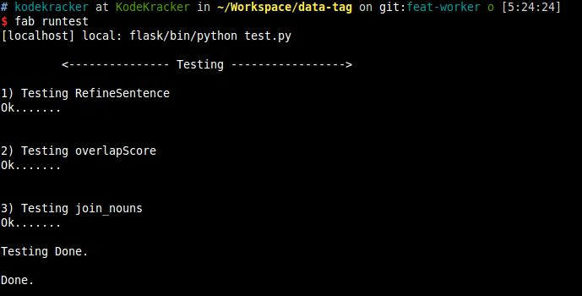

Figure 10. Test Report

16

1. **Installation Instructions**

Prerequisites to run Data­Tag on local machine consist of **npm**, **python 2.7**, **git** and **redis**. Although Data­tag is a web application, one can still run it locally using followinginstructions:

**a).** Use git clone to clone this repo to your local machine: **$ git clone https://github.com/rishy/data­tag.git**

**b).** Install all the dependencies using npm install:

**$ npm install**

**c).** Install all the bower packages:

**$ bower install**

**d).** for first time, install a virtual environment in root directory using install.sh (orinstall.bat for Windows):

* **chmod +x install.sh**
* **./install.sh**

**e).** First install Fabric to run below commands

**$ sudo pip install fabric**

**f).** To install all dependencies in requirements.txt:

**$ fab installDep**

**g).** To run the app :

**$ fab runapp**

**h).** Start redis server service from within the redis installation folder using:

**$ src/redis­server**

**i).** To run the worker :

**$ fab runworker**

App will run on [**http://127.0.0.1:5000/**](http://www.google.com/url?q=http%3A%2F%2F127.0.0.1%3A5000%2F&sa=D&sntz=1&usg=AFQjCNHtr0hYkWzKcq0gk_EMbZN0-TrsRA)

17

1. **End­User Instructions**

Data­Tag provides two different options for an user to provide input:

* Web URL
* Raw Textual Data

Both of these options are available through the tabs on the top of the input boxes, namely ­ **url** and **text.** “URL” tab accepts any **valid url** same goes with the “text” tab.

After entering the appropriate data in any one of the input box, hit the “Tag It!” button. Since, there is a lot of data processing involved, once you click on the “Tag It!” button a loader will show tokenized words below the input boxes, which indicates that the data is being processed.

Once, Data­Tag system gets done with processing and classifying data, an output will be shown below the input boxes in the form of summary of classes. There will also be a “Read More” button in every summary, which redirects the user to the specific Wikipedia page.

A fixed number of **three tags** are returned by Data­Tag and the performance as well as efficiency depends on the length of input data. So, more input data will take more take and vice­versa.

Avoid providing a very large input, which will generally take a considerable amount of time to process. You can still classify the data just by using a part of the textual document, preferably of **less than 10000** words.

As far as “url” input is concerned you can provide any url containing text. Data­tag only fetches text from the page so any other information like images, videos will be discarded completely.

18

1. **Future Work**

Some of the possible amendments and improvements in this system are:

* Adding a Web Crawler
* Using Machine Learning techniques for Lexical Scoping
* NLP Query Formulation based on input data

A **Web Crawler** can be included with this project to automatically classify web pages. Instead of taking input manually a web crawler will simply pick web pages one by one and will tag them using the existing Data­Tag system. In this way we can get a **semantic** **record** of web pages from all around the internet. Although this amendment requires areally large database and processing power, but it can easily be fulfilled with adequate hardware.

By employing **Machine Learning** techniques this system may further be enhanced for better results. Supervised learning is the most preferable approach for the same it’s easy to implement and train. Although a Supervised approach will need a large amount of training data, which we can hopefully get from Wikipedia to train the system.

**NLP Query Formulation** may increase the importance of this system by ten­folds. Bymerging Web Crawler and NLP query formulation may provide us appropriate queries for each and every page. When a user asks for any of these queries mapped pages to those queries can be shown to user, resulting in a more intelligent text search over internet.

19

1. **Summary**

Systems like Data­Tag are the future of semantic text over internet. It aims in dropping age­old keyword based classification systems and welcomes the advent of more Artificially Intelligent systems. It further provides a basic structure to develop larger systems utilizing the similar concepts to classify data all over the internet and textual documents. By providing more meaningful information to user Data­Tag increases the overall user experience and satisfy users quest for smart textual and web search.

20

1. **References**
   * [http://web.eecs.umich.edu/~mihalcea/papers/mihalcea.naacl07.pdf](http://www.google.com/url?q=http%3A%2F%2Fweb.eecs.umich.edu%2F~mihalcea%2Fpapers%2Fmihalcea.naacl07.pdf&sa=D&sntz=1&usg=AFQjCNHGrEXcXtvm6B1s3I3FdIQDMG96ug)
   * [http://www.semantic­web­journal.net/sites/default/files/swj170.pdf](http://www.google.com/url?q=http%3A%2F%2Fwww.semantic-web-journal.net%2Fsites%2Fdefault%2Ffiles%2Fswj170.pdf&sa=D&sntz=1&usg=AFQjCNHHkT8eeVEJcY2MnfLa5AGmQKg0fQ)
   * [http://en.wikipedia.org/wiki/Word­sense_disambiguation](http://www.google.com/url?q=http%3A%2F%2Fen.wikipedia.org%2Fwiki%2FWord-sense_disambiguation&sa=D&sntz=1&usg=AFQjCNGkqKhm8zSu1qWscOTaynYbcjRFrg)
   * [http://www.nltk.org/](http://www.google.com/url?q=http%3A%2F%2Fwww.nltk.org%2F&sa=D&sntz=1&usg=AFQjCNEXq0RaqdC_NoBLtmIYwOgOFSZKDw)
   * https://github.com/rishy/data­tag